EXPT NO 2 Configure VLANs and inter-VLAN routing in Packet Tracer
Objectives:
(ii) To configure Inter-VLAN Routing to enable communication between devices belonging to different VLANs.
Software/Apparatus required:
(i) Cisco Packet Tracer
(ii) End Devices (PCs)
(iii) Switches
(iv) Copper Straight-through Cable / Automatic Cable Selector
(v) Routers
Procedure:
Objective 2: Inter-VLAN configuration
1. Open Cisco Packet Tracer.
2. Place one router, three switches, and six PCs in the workspace.
3. Connect the PCs to their respective switches using straight-through cables.
4. Connect the access switches to the central switch.
5. Connect the router to the central switch.
6. Create VLAN 10 and VLAN 20 on the switches.
7. Assign the ports connected to PC0, PC1, and PC2 to VLAN 10.
8. Assign the ports connected to PC3, PC4, and PC5 to VLAN 20.
9. Configure the links between the switches as trunk links.
10. Configure the router interfaces to route traffic between VLAN 10 and VLAN 20.
11. Configure the required network settings on all PCs.
12. Verify communication between devices within the same VLAN.
13. Verify communication between devices belonging to different VLANs through the
router.
14. Save the configuration and observe the results.
Networking diagram:
Objective 2: Inter-VLAN Configuration
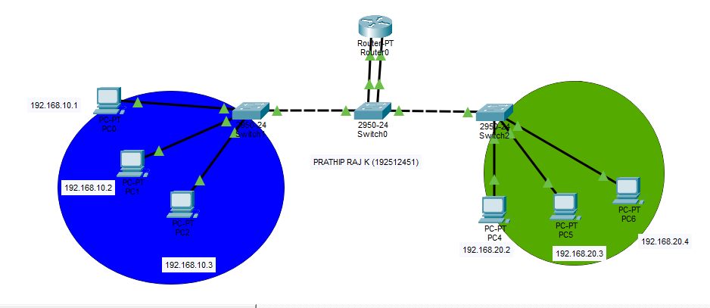
Output:
Objective (ii): Inter-VLAN Configuration
Sl. No | Source IP | Destination IP | Data sent (bytes) | Data received (bytes)
1 | 192.186.32.2 | 192.186.32.4 | 4 | 4
2 | 192.186.32.5 | 192.186.32.1 | 4 | 4
3 | 192.186.32.4 | 192.186.32.3 | 4 | 4
4 | 192.186.32.3 | 192.186.32.6 | 4 | 4
5 | 192.186.32.1 | 192.186.32.3 | 4 | 4

Result:
Objective 2: Inter-VLAN Configuration
(ii) Inter-VLAN Routing was successfully configured, enabling communication between devices belonging to different VLANs through the router.

